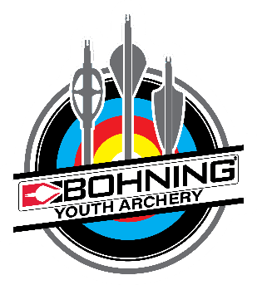
Bohning Youth Archery Program
Over our 75+ year history Bohning has supported youth archery programs across the US and internationally. We hope to inspire lifelong interest in the sport of archery, whether that is through target archery or hunting.
We love to partner with Archery Clubs and Schools to promote fun, safe, and responsible habits in our youngest participants of the sport we all enjoy.

What we are offering:
- Bohning will supply each approved youth archery club/school a 42.5% discount off retail pricing on all Bohning products purchased through the club. Members of your club can receive this same discount with proof of club membership.
- Support for any questions concerns regarding our products.
- A Bohning banner to hang at your club.
- A FREE welcome package that includes Bohning Youth Archery stickers, and our top-of-the-line fletching jig.

What we’d like from you:
- The club must complete the attached Youth Archery Club Application
- Send us a picture of the members of your club (preferably in front of our banner once you receive it).
- Notification of events and wins your club has so we can promote you through our social media.
- Send images at least 2 times annually of events, practices, tournaments, club members or students (see application regarding photo releases).

We welcome you to fill out our Archery Club Application. If you have any questions, please feel free email us at:
info@bohning.com or call us at 231-229-4247.
Youth Archery Club Application
All information will be kept confidential and used only in the setup of an account
with the Bohning Company.
It is necessary to complete this application before any shipments can be made as part of the Bohning Youth Archery program.
All orders made through the Bohning Youth Archery Program must be prepaid using a credit card.

Club Name:
Mailing Address: | Shipping Address:
Phone:
Email: | Contact Name:
Number of Club Members: | Tax ID: ______________________________  Clubs unable to provide a Tax ID or Tax-Exempt Certificate will be required to pay sales tax where applicable
Age Range of Club Members: | I have read and agree to the Photo Release Statement below
Number of Club Coaches:

The Bohning Company Youth Archery Program is for clubs with members 18 and younger. To be a part of the Bohning Company Youth Archery program, clubs must display a Bohning banner, supply a picture of the club participants and twice annually supply the Bohning Company with pictures of events, trophies won, etc.

Photo Release Statement:
I agree that the club/school holds a minor(child) release form for all images provided to Bohning Archery now or anytime in the future. Use of provided photos may include, but are not limited to, the following: publicity, copyright purposes, illustrations, advertising and web content. Furthermore, I understand that no royalty fee, or other compensation shall become payable to me by reason of such use. Bohning can supply a sample Photo Release Form for use by the club if requested.

I am applying for a Youth Archery account. The information given on this application is true and correct to the best of my knowledge.

Signed: ________________________________________________ Date: ________________

Return this application along with a copy of sales tax-exempt certificate:

The Bohning Company Fax: 231-229-4615
7361 North 7 Mile Road
Lake City MI 49651 info@bohning.com

